**BÀI TẬP VỀ NHÀ**

**MÔN KỸ THUẬT ROBOT**

Tên: Nguyễn Thanh Văn

MSSV: 20146181

**Bài 1: Vẽ trái tim**

syms l1 l2 l3 t t1 t2 c1 s1 c2 s2

l1 = 15;

l2 = 10;

for t=-pi:0.1:pi

X = 16*(sin(t)^3);

Y = 13*cos(t) - 5*cos(2*t) - 2*cos(3*t) - cos(4*t);

c2 = (X^2 + Y^2 - l1^2 - l2^2)/(2*l1*l2); %cos(t2) = (Px^2 + Py^2 - l1^2 - l2^2)/(2*l1*l2)

s2 = sqrt(abs(1-c2^2)); %sin(t2) = sqrt(abs(1-cos(t2)^2))

t2 = atan2(s2,c2);

c1 = X*(l1+l2*c2) + Y*l2*s2;

s1 = Y*(l1 + l2*c2) - X*l2*s2;

t1 = atan2(s1,c1);

Px = l1*cos(t1) + l2*cos(t1+t2);

Py = l1*sin(t1) + l2*sin(t1+t2);

%ve trai tim

subplot(2,1,1);

plot(t,t2*180/pi,'*');

pause(0.01);

xlabel('t'); ylabel('rotation')

hold on

subplot(2,1,2);

plot(Px,Py,'*'); pause(0.01);

xlabel('x(cm)'); ylabel('y(cm)');

pause(0.01);

hold on

end

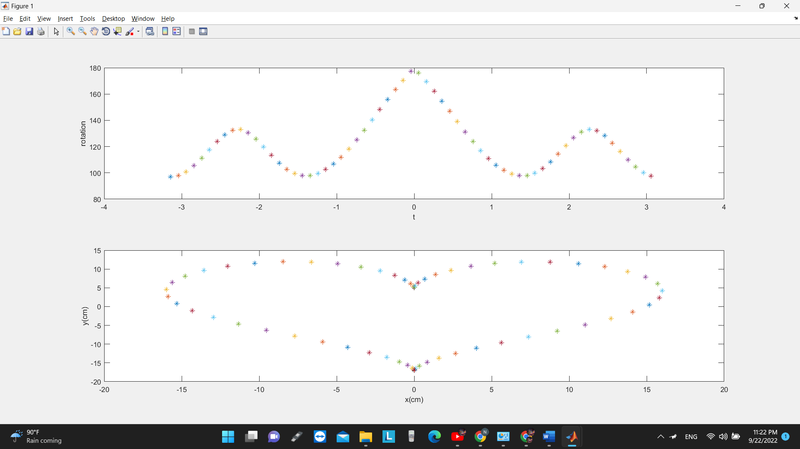

**Bài 2: Vẽ con bướm**

syms l1 l2 l3 t t1 t2 c1 s1 c2 s2 e

l1 = 5;

l2 = 5;

for t=0:0.1:2*pi

X = sin(t)*(exp(cos(t)) - 2*cos(4*t) - sin(t/12)^5);

Y = cos(t)*(exp(cos(t)) - 2*cos(4*t) - sin(t/12)^5);

c2 = (X^2 + Y^2 - l1^2 - l2^2)/(2*l1*l2); %cos(t2) = (Px^2 + Py^2 - l1^2 - l2^2)/(2*l1*l2)

s2 = sqrt(abs(1-c2^2)); %sin(t2) = sqrt(abs(1-cos(t2)^2))

t2 = atan2(s2,c2);

c1 = X*(l1+l2*c2) + Y*l2*s2;

s1 = Y*(l1 + l2*c2) - X*l2*s2;

t1 = atan2(s1,c1);

Px = l1*cos(t1) + l2*cos(t1+t2);

Py = l1*sin(t1) + l2*sin(t1+t2);

%ve buom

subplot(2,1,1);

plot(t,t2*180/pi,'*');

pause(0.01);

xlabel('t'); ylabel('rotation')

hold on

subplot(2,1,2);

plot(Px,Py,'*'); pause(0.01);

xlabel('x(cm)'); ylabel('y(cm)');

pause(0.01);

hold on

end

**Bài 3: Hoa 5 cánh**

syms l1 l2 l3 t t1 t2 c1 s1 c2 s2 e

l1 = 10;

l2 = 10;

for t=0:0.1:5*pi

X = cos(5*t)*cos(t);

Y = cos(5*t)*sin(t);

c2 = (X^2 + Y^2 - l1^2 - l2^2)/(2*l1*l2); %cos(t2) = (Px^2 + Py^2 - l1^2 - l2^2)/(2*l1*l2)

s2 = sqrt(abs(1-c2^2)); %sin(t2) = sqrt(abs(1-cos(t2)^2))

t2 = atan2(s2,c2);

c1 = X*(l1+l2*c2) + Y*l2*s2;

s1 = Y*(l1 + l2*c2) - X*l2*s2;

t1 = atan2(s1,c1);

Px = l1*cos(t1) + l2*cos(t1+t2);

Py = l1*sin(t1) + l2*sin(t1+t2);

%ve hoa nam canh

subplot(2,1,1);

plot(t,t2*180/pi,'*');

pause(0.01);

xlabel('t'); ylabel('rotation')

hold on

subplot(2,1,2);

plot(Px,Py,'*'); pause(0.01);

xlabel('x(cm)'); ylabel('y(cm)');

pause(0.01);

hold on

end

**Bài 4: Hoa sáu cánh**

syms l1 l2 l3 t t1 t2 c1 s1 c2 s2 e

l1 = 7;

l2 = 7;

for t=0:0.1:12*pi

X = (1+cos(6*t))*cos(t);

Y = (1+cos(6*t))*sin(t);

c2 = (X^2 + Y^2 - l1^2 - l2^2)/(2*l1*l2); %cos(t2) = (Px^2 + Py^2 - l1^2 - l2^2)/(2*l1*l2)

s2 = sqrt(abs(1-c2^2)); %sin(t2) = sqrt(abs(1-cos(t2)^2))

t2 = atan2(s2,c2);

c1 = X*(l1+l2*c2) + Y*l2*s2;

s1 = Y*(l1 + l2*c2) - X*l2*s2;

t1 = atan2(s1,c1);

Px = l1*cos(t1) + l2*cos(t1+t2);

Py = l1*sin(t1) + l2*sin(t1+t2);

%ve hoa sau canh

subplot(2,1,1);

plot(t,t2*180/pi,'*');

pause(0.01);

xlabel('t'); ylabel('rotation')

hold on

subplot(2,1,2);

plot(Px,Py,'*'); pause(0.01);

xlabel('x(cm)'); ylabel('y(cm)');

pause(0.01);

hold on

end

